N+ Network Security
SOHO Network
1. Draw a network diagram for a small office/home office (SOHO) setup that includes: one broadband internet connection, one Wi-Fi router, two laptops, one smart TV, and one printer. Clearly label each device and connection type (wired or wireless).
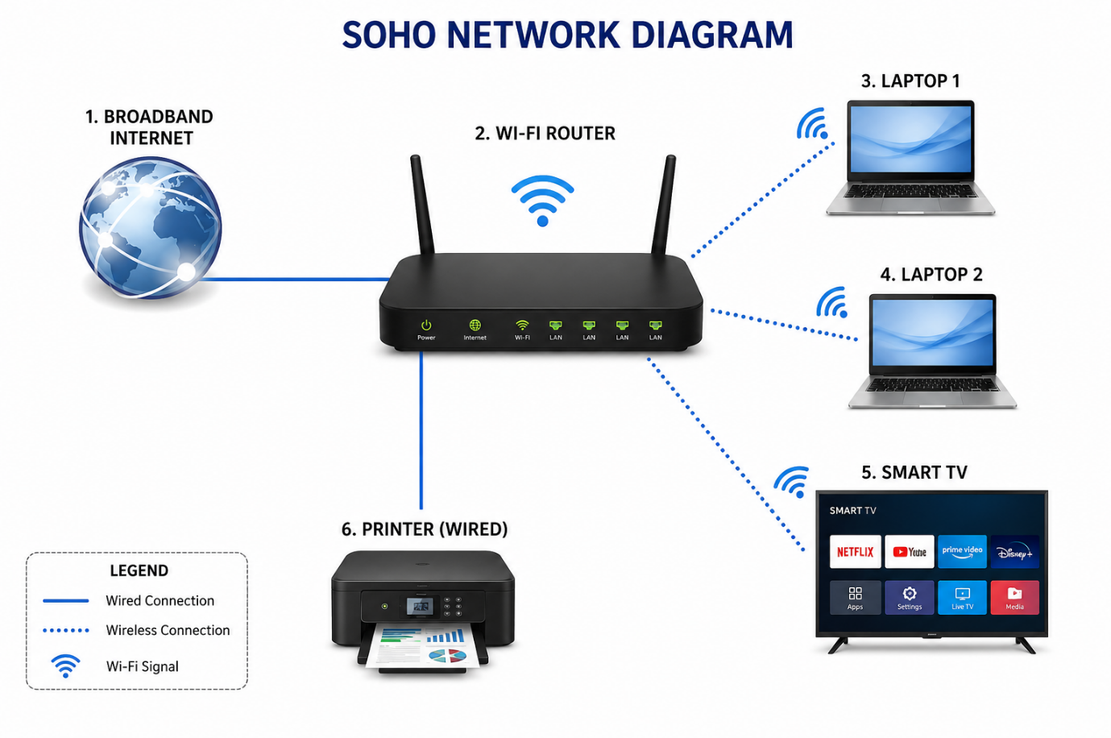
2. List all the hardware components (with brand/model suggestions) you would need to physically build the SOHO network diagrammed above, including cables and any switches or extenders if needed.<br><br><em><strong>Hint:</strong> Check current listings on Flipkart or Amazon for typical device models used in Indian homes/offices.</em>
=
Component | Suggested Brand/Model | Purpose
ISP Modem/ONT | ISP-provided (JioFiber, Airtel Xstream, BSNL FTTH) | Connects to the internet
Wi-Fi Router | TP-Link Archer C64 / Archer C6 / D-Link Eagle Pro R15 | Shares internet and provides Wi-Fi. Wi-Fi 6 is a good choice for new setups.
Gigabit Network Switch (8-Port) | TP-Link TL-SG1008D or Tenda SG108M | Adds extra LAN ports for multiple wired devices.
CAT6 Ethernet Cables | Sounce / Fedus CAT6 | Connect PCs, printer, switch, and router
Wi-Fi Range Extender (optional) | TP-Link RE205 or TL-WA850RE | Extends Wi-Fi coverage in larger homes/offices
Network Printer | HP LaserJet / Epson EcoTank (Ethernet or Wi-Fi) | Shared printing for all users
UPS (optional) | APC or Zebronics UPS | Keeps router and switch running during power cuts

3. Write step-by-step instructions to configure the Wi-Fi router for your SOHO network, including setting up a unique SSID, enabling WPA2 security, and changing the default admin password.
- = Connect the router to the modem/ONT and power it on.
- Connect your PC or phone to the router using Wi-Fi or a LAN cable.
- Open a web browser and enter the router's IP address (e.g., 192.168.0.1 or 192.168.1.1).
- Log in using the default username and password (found on the router label).
- Go to Wireless Settings and change the SSID (Wi-Fi name) to a unique name (e.g., SOHO_Office).
- Set the Security Mode to WPA2-PSK (AES).
- Create a strong Wi-Fi password (at least 12 characters with letters, numbers, and symbols).
- Open the Administration/System settings and change the default router admin password to a strong new password.
- Save the settings and allow the router to reboot if required.
- Reconnect your devices using the new SSID and Wi-Fi password, then test the internet connection.
4. Configure IP addresses for all devices in your SOHO network: assign static IPs to the printer and smart TV, and use DHCP for the laptops. Show a table listing each device, its MAC address (make one up), and the assigned IP address.
=
Device | MAC Address (Example) | IP Address | Assignment
Wi-Fi Router | 00:1A:2B:3C:4D:01 | 192.168.1.1 | Static (Gateway)
Laptop 1 | A4:2C:11:9D:5E:01 | 192.168.1.100 | DHCP
Laptop 2 | A4:2C:11:9D:5E:02 | 192.168.1.101 | DHCP
Laptop 3 | A4:2C:11:9D:5E:03 | 192.168.1.102 | DHCP
Laptop 4 | A4:2C:11:9D:5E:04 | 192.168.1.103 | DHCP
Laptop 5 | A4:2C:11:9D:5E:05 | 192.168.1.104 | DHCP
Network Printer | B8:27:EB:45:67:89 | 192.168.1.10 | Static
Smart TV | 3C:5A:B4:12:34:56 | 192.168.1.20 | Static

5. Explain how you would troubleshoot if one of the laptops cannot connect to the internet in your SOHO network. List at least 3 possible causes and what steps you would take to diagnose and fix each issue.
=
Possible Cause | Diagnosis | Fix
Wi-Fi not connected or wrong password | Check if the laptop is connected to the correct SSID and verify the Wi-Fi password. | Reconnect to the correct Wi-Fi and enter the correct password.
No IP address assigned (DHCP issue) | Run ipconfig and check if the laptop has a valid IP address (e.g., 192.168.1.x). | Renew the IP address (ipconfig /release and ipconfig /renew) or restart the router.
Router or Internet connection problem | Test internet access on other devices and ping the router (ping 192.168.1.1). | Restart the router/modem and check ISP connectivity. If only one laptop is affected, restart its network adapter or update the network driver.

